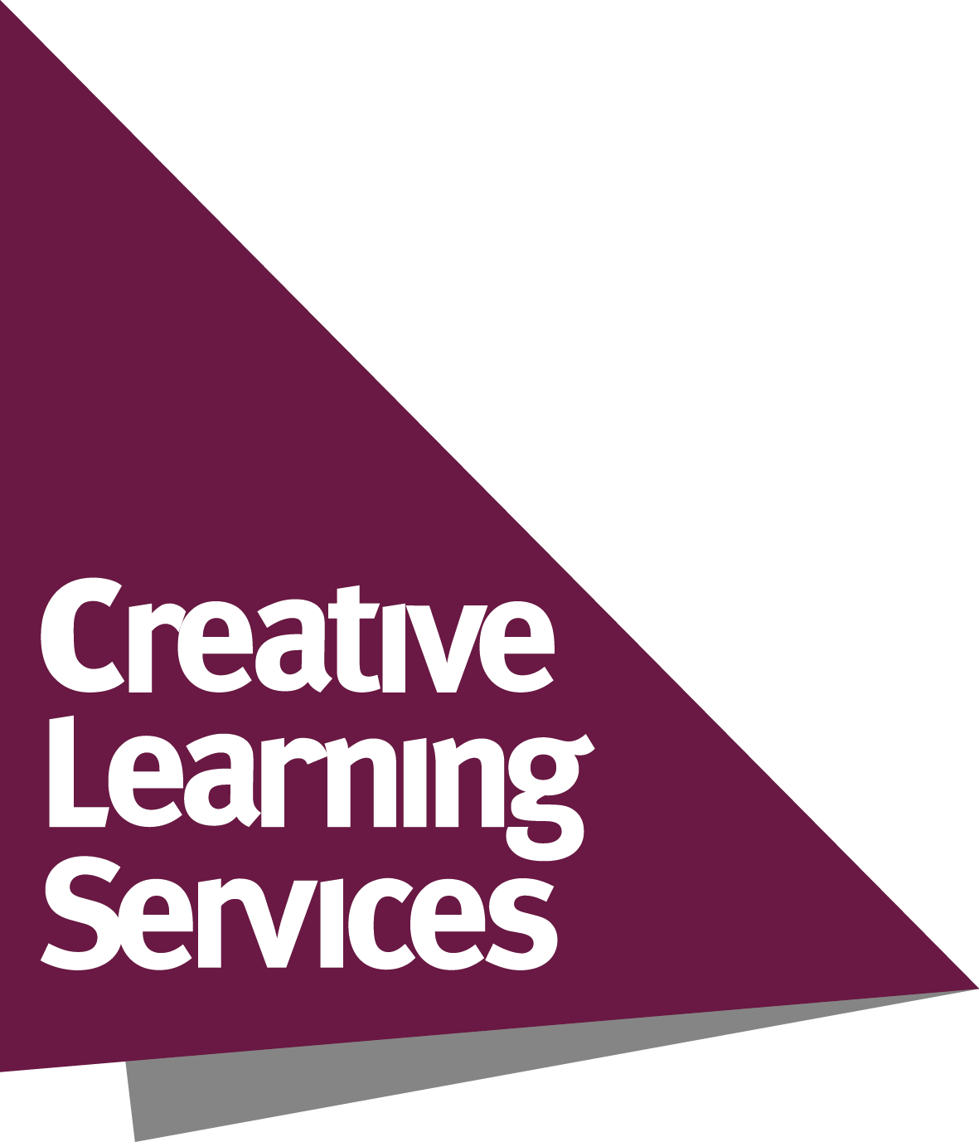
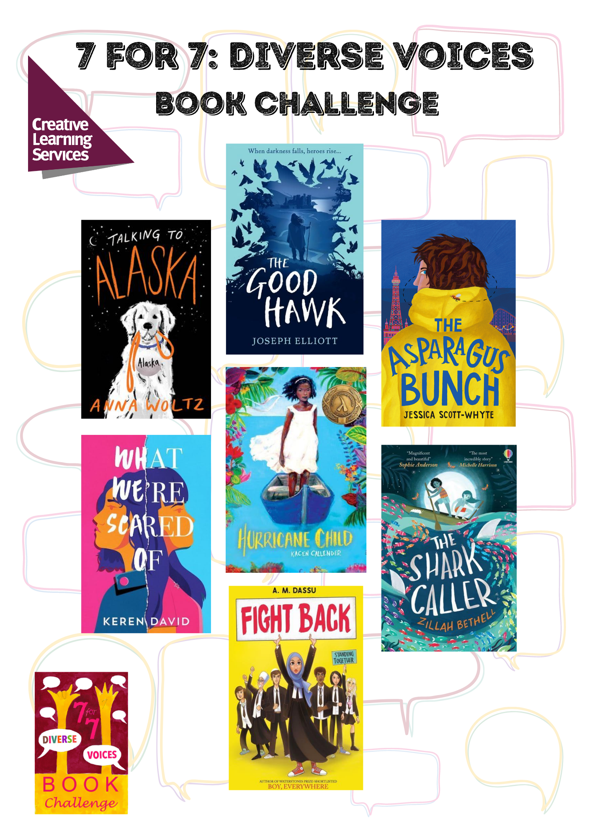
7 for 7: Diverse Voices Book Challenge
Aims to...
- Inspire and motivate more able students in Year 7 to be active readers
- Develop and support reading for pleasure, reading widely and often and reading stamina
- Develop awareness of new titles and authors
- Provide schools with copies of great challenging books and discussion ideas
- Raise the profile of the School Library and its staff and encourage closer working with the English Department
- Develop awareness of different perspectives and viewpoints through reading about a range of diverse characters.

The full 7 for 7: Diverse Voices Book Challenge package includes:
- 35 books with plastic jackets fitted – 5 copies of each of these 7 titles:

Author | Title
Zillah Bethell | The Shark Caller
Kacen Callender | Hurricane Child
A. M. Dassu | Fight Back
Keren David | What We’re Scared Of
Joseph Elliott | The Good Hawk
Jessica Scott-Whyte | The Asparagus Bunch
Anna Woltz | Talking to Alaska

- Invitation to attend free virtual and in-school author events
- Supporting resources such as Discussion Sheets for each title, a Further Reading booklet and a suggested calendar
- Access to virtual content
- Promotional materials – posters, bookmarks and award certificates
- Chance to enter the 7 for 7: Diverse Voices competition!
Additional sets of the books can be ordered overleaf, and multiple packages can be purchased.
Please note all resources and promotional materials will be sent electronically for you to add your own school logo before printing, displaying on screens or sending electronically yourselves.

If you have any questions, please contact Claire Purdon claire.purdon@leics.gov.uk
7 for 7: Diverse Voices Order Form

I wish to purchase the 7 for 7: Diverse Voices Book Challenge as follows: | Number of packages
As part of my Creative Learning Services subscription for 2022-23
(1 purple module per package)
Pay As You Go package for non-subscribers for £450
(school to be invoiced separately)
Additional sets of the 7 books at £50 each
Total modules or cost to be invoiced:

School name
Name of contact in school
Position in school
Email address
Signature
Date

Please return your order form to:
Creative Learning Services
Post: Eastern Annexe, County Hall, Glenfield, Leicestershire, LE3 8SS
Email: claire.purdon@leics.gov.uk

