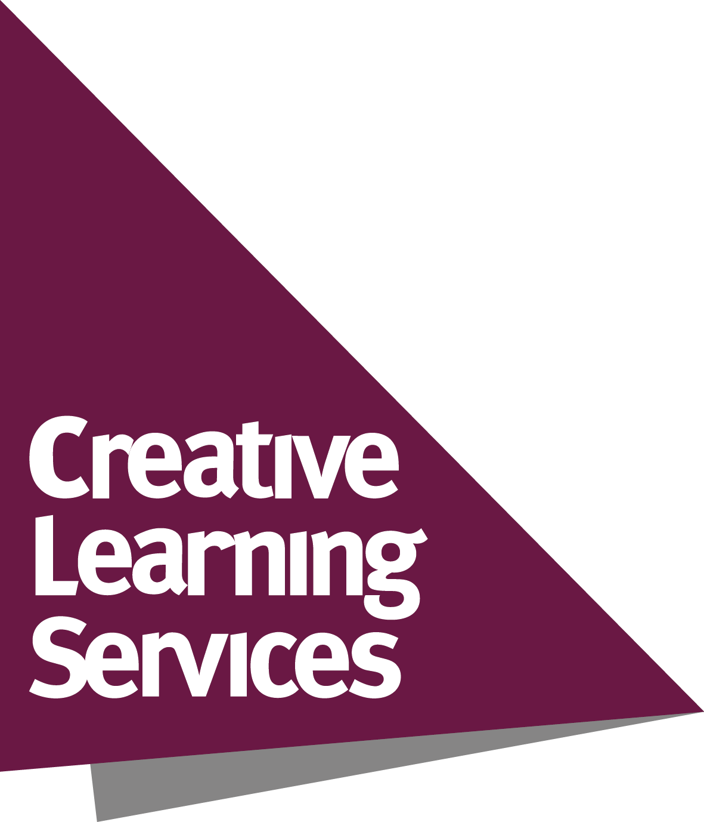
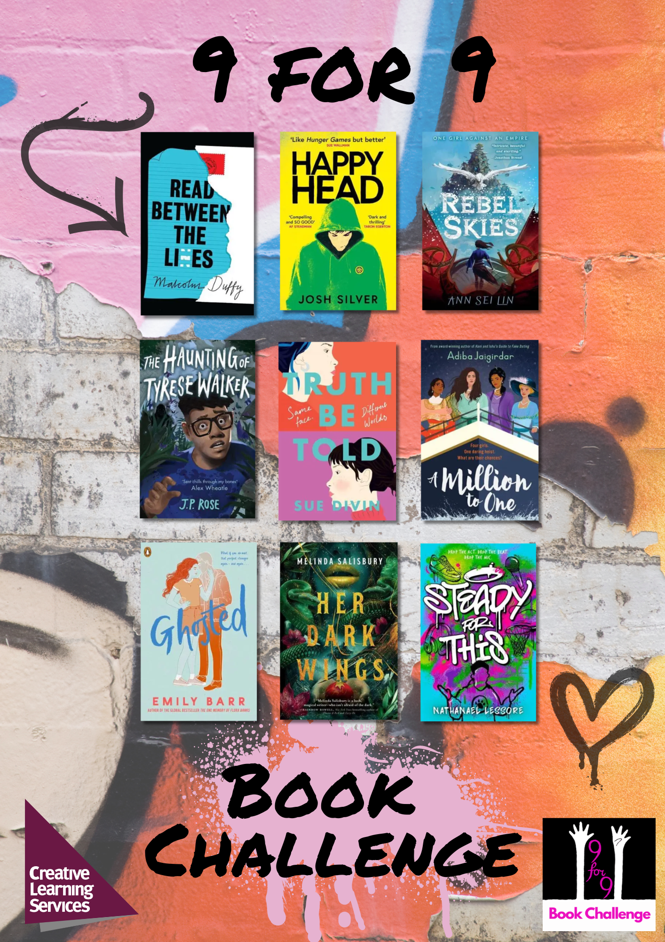
9 for 9 Book Challenge
Aims to...
- Inspire and motivate Year 9 students to be active readers
- Develop and support reading for pleasure, reading widely and often and reading stamina
- Develop awareness of new titles and authors
- Provide schools with copies of great challenging books and discussion ideas
- Raise the profile of the School Library and its staff and encourage closer working with the English Department
- Develop awareness of different perspectives and viewpoints through reading about a range of diverse characters.

The full 9 for 9 Book Challenge package includes:
- 36 books with plastic jackets fitted – 4 copies of each of these 9 titles*:

Title | Author
Ghosted | Emily Barr
Truth Be Told | Sue Divin
Read Between the Lies | Malcolm Duffy
A Million to One | Adiba Jaigirdar
Steady for This | Nathanael Lessore
The Haunting of Tyrese Walker | J. P. Rose
Her Dark Wings | Melinda Salisbury
Rebel Skies | Ann Sei Lin
Happy Head | Josh Silver

- Invitation to attend a staff launch event and termly virtual author events
- Supporting resources such as discussion sheets and activities for each title
- Access to virtual content
- Promotional materials – posters, bookmarks and award certificates
- Chance to enter the 9 for 9 competition and win great prizes!

If you have any questions, please contact Claire Purdon claire.purdon@leics.gov.uk
*Book titles may be subject to change
9 for 9 Order Form

I wish to purchase the 9 for 9 Book Challenge as follows: | Number of packages
9 for 9 package at a cost of £450
(school to be invoiced separately)
Total cost to be invoiced:

School name
Order number (please provide this from your school finance department)
Name of contact in school
Position in school
Email address
Signature
Date

Please return your order form to:
Creative Learning Services
Post: Eastern Annexe, County Hall, Glenfield, Leicestershire, LE3 8SS
Email: claire.purdon@leics.gov.uk

