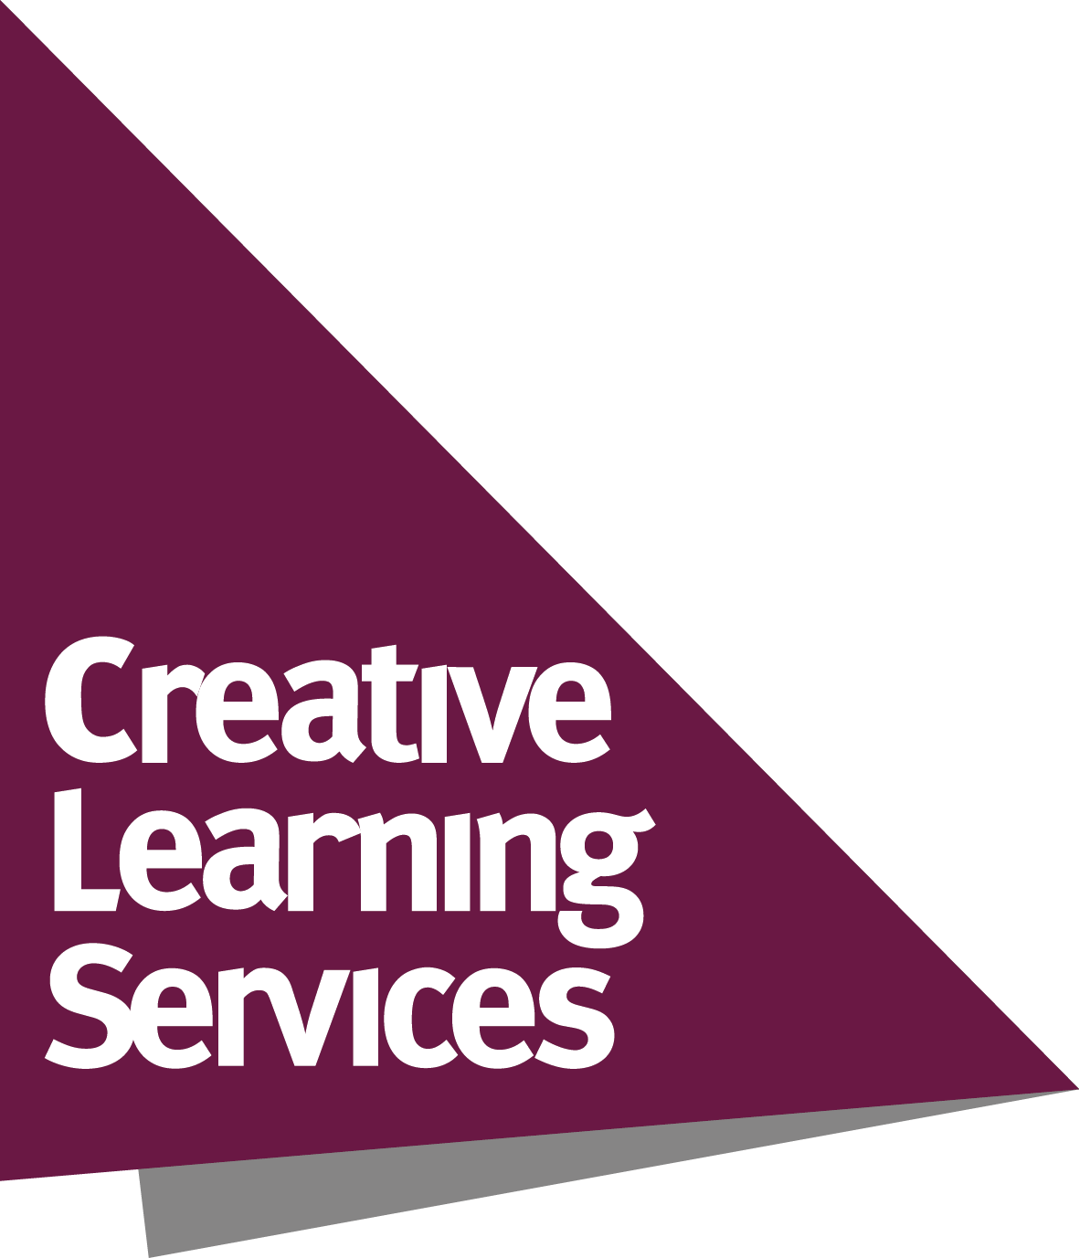
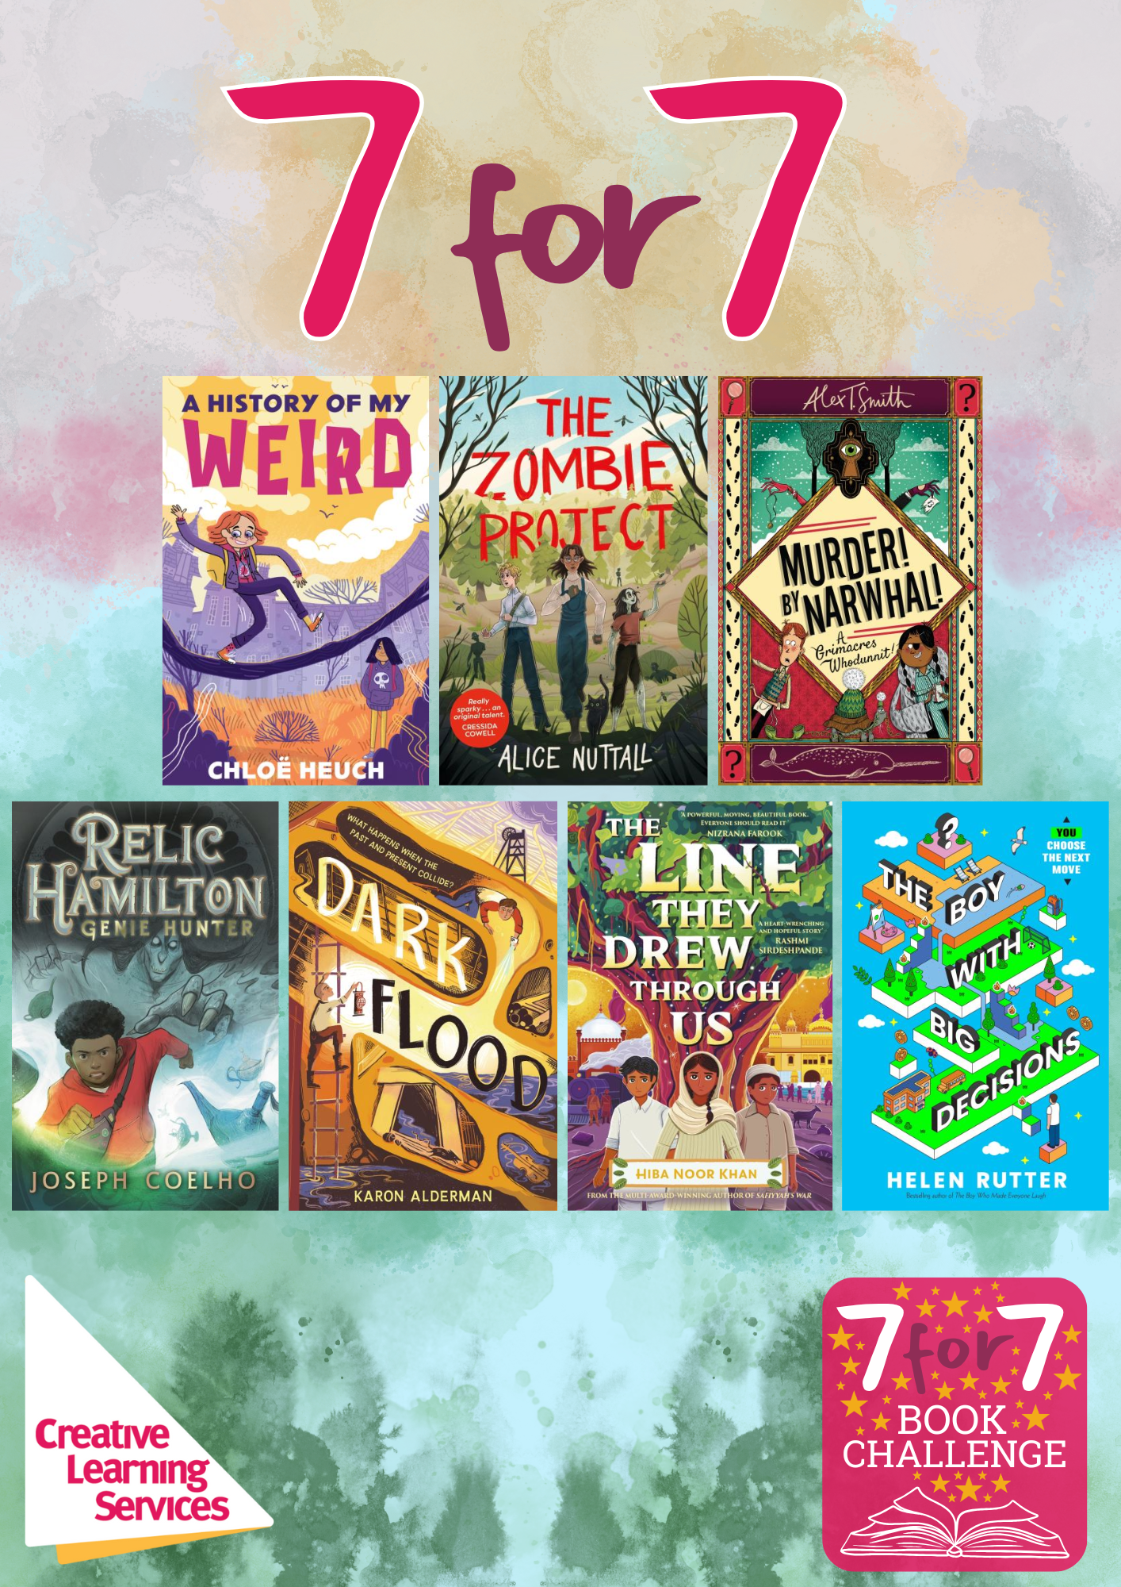
7 for 7 Book Challenge
Aims to...
- Inspire and motivate Year 7 students to be active readers during their transition to secondary
- Develop and support reading for pleasure, reading widely and often, and reading stamina
- Develop awareness of new titles and authors
- Provide schools with copies of great challenging books and discussion ideas
- Raise the profile of the School Library and its staff and encourage closer working with the English Department
- Develop awareness of different perspectives and viewpoints through reading about a range of diverse characters

The full 7 for 7 Book Challenge package includes:
- 28 books with plastic jackets fitted – 4 copies of each of these 7 titles*:

Title | Author
A History of My Weird | Chloe Heuch
Dark Flood | Karon Alderman
Murder! By Narwhal! | Alex T. Smith
Relic Hamilton: Genie Hunter | Joseph Coelho
The Boy with Big Decisions | Helen Rutter
The Line They Drew Through Us | Hiba Noor Khan
The Zombie Project | Alice Nuttall

- Invitation to attend a staff launch event and live virtual author events
- Supporting resources such as discussion sheets and activities for each title
- Access to virtual content
- Promotional materials – posters, bookmarks and award certificates
- Chance to enter the 7 for 7 competition and win great prizes!
If you have any questions, please contact Alyssia Chapman Alyssia.chapman@leics.gov.uk
*Book titles may be subject to change
7 for 7 Order Form

I wish to purchase the 7 for 7 Book Challenge as follows: | Number of packages
7 for 7 package at a cost of £475
(school to be invoiced separately)
Total cost to be invoiced:

School name
Purchase Order number (please provide this from your school finance department)
Name of contact in school
Position in school
Email address
Signature
Date

Please return your order form to:
Creative Learning Services
Post: Eastern Annexe, County Hall, Glenfield, Leicestershire, LE3 8SS
Email: Alyssia.chapman@leics.gov.uk

